Lab 1

Task 1

AND Gate

Dataflow Model
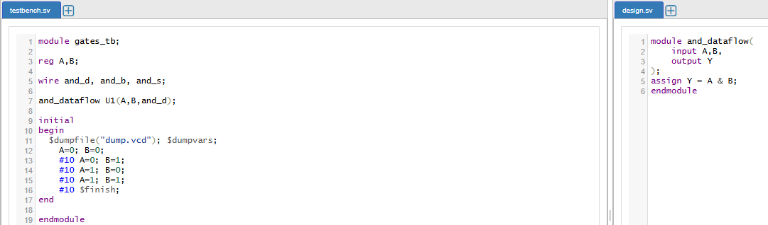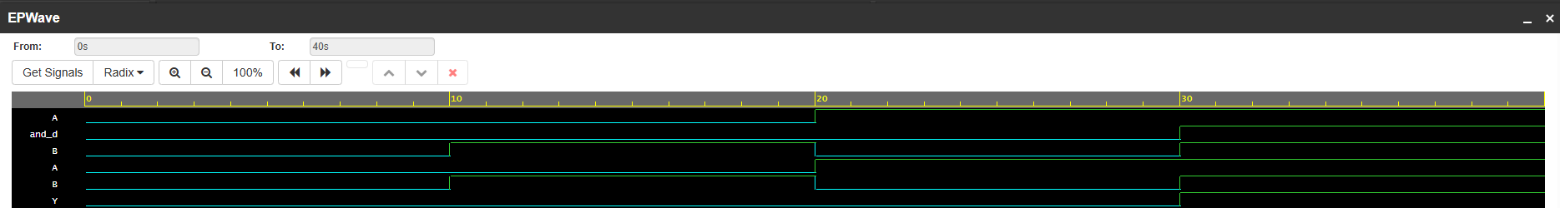
Behavioral Model
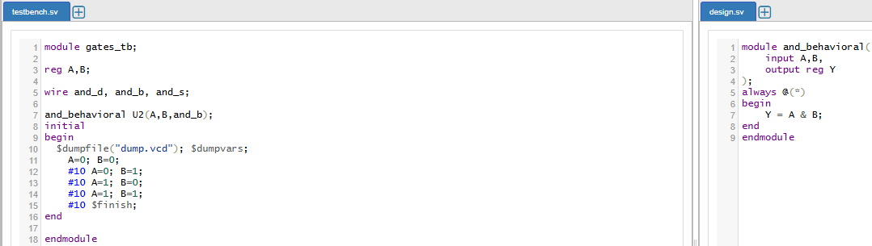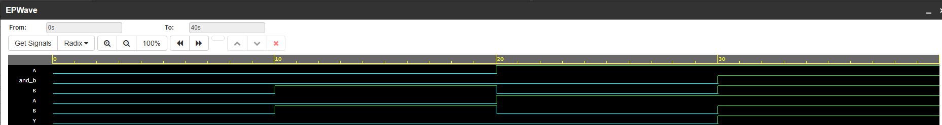
Structural Model
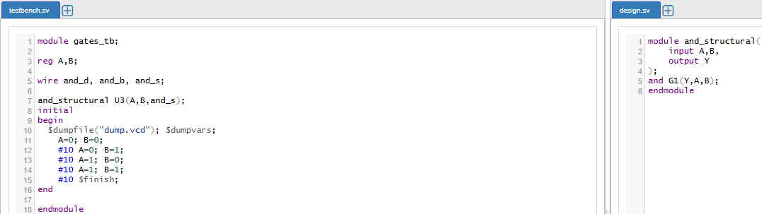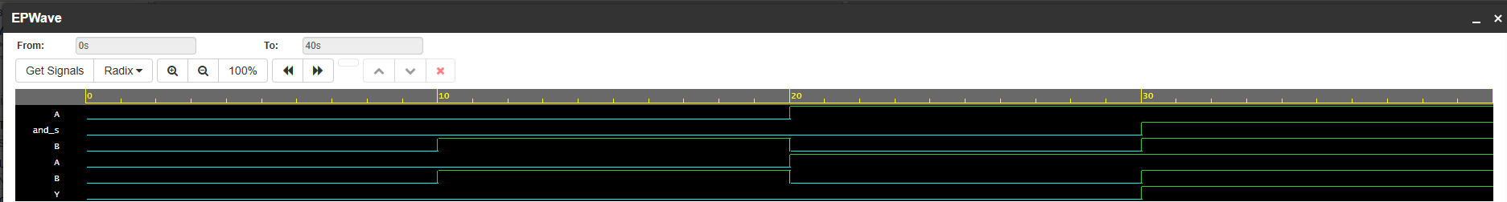

OR Gate

Dataflow Model
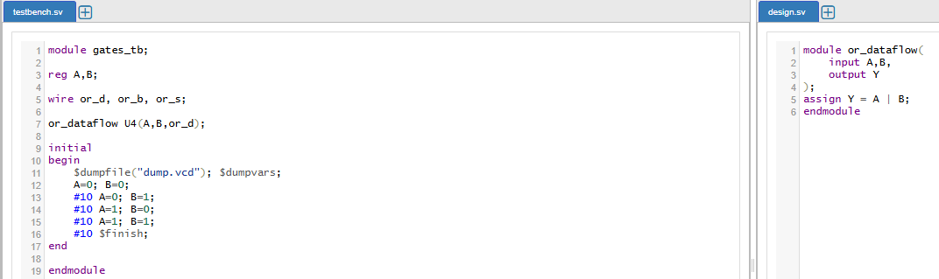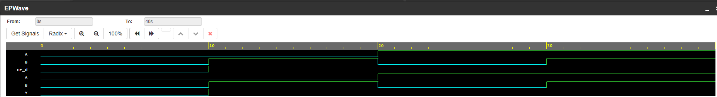

Behavioral Model
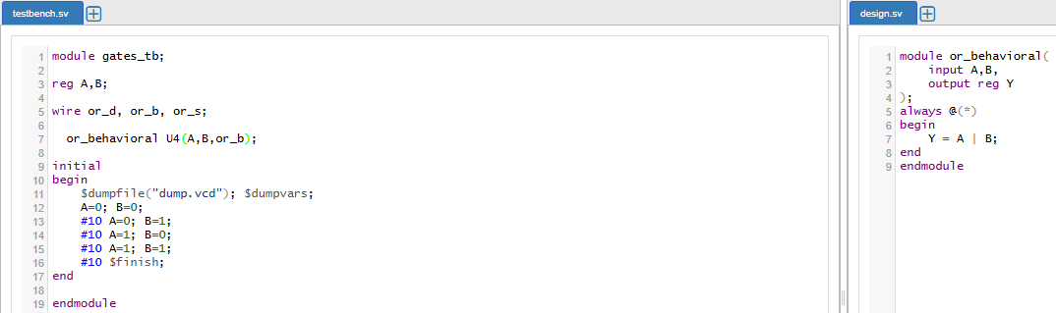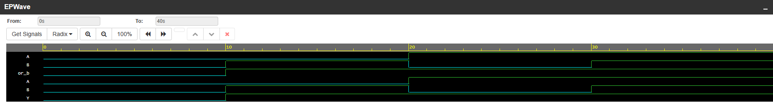
Structural Model

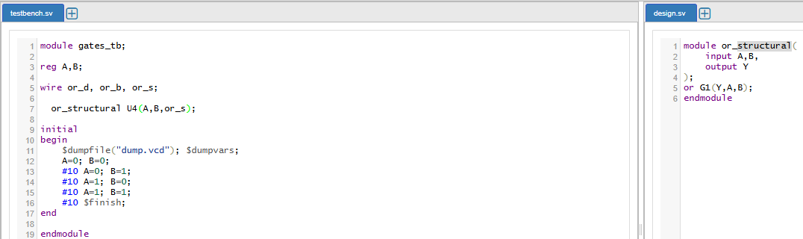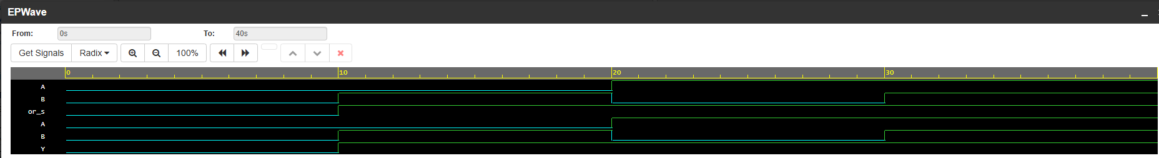

XOR Gate

Dataflow Model
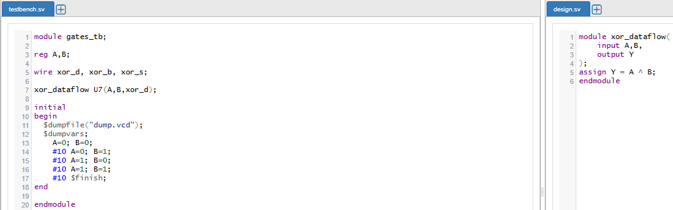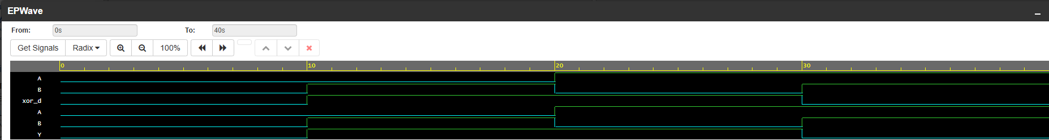
Behavioral Model
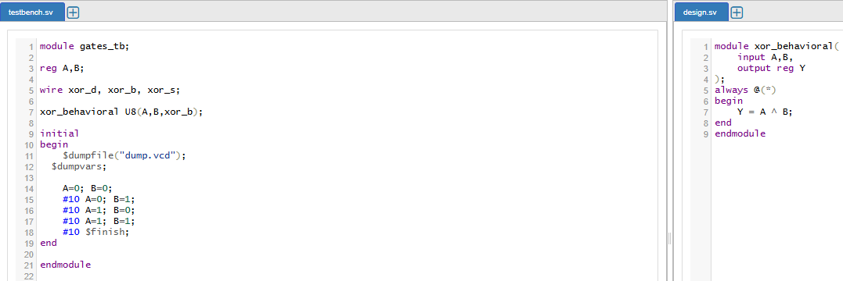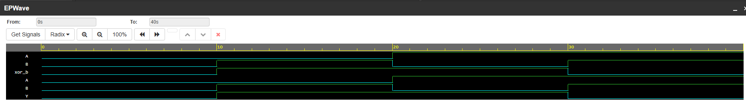

Structural Model
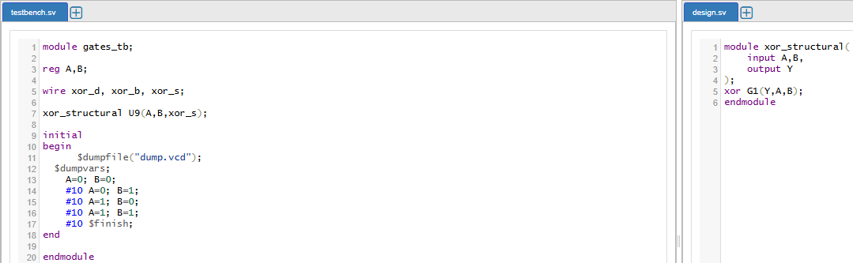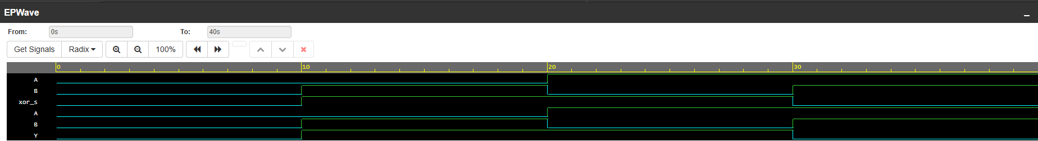
Task 2
Half Adder
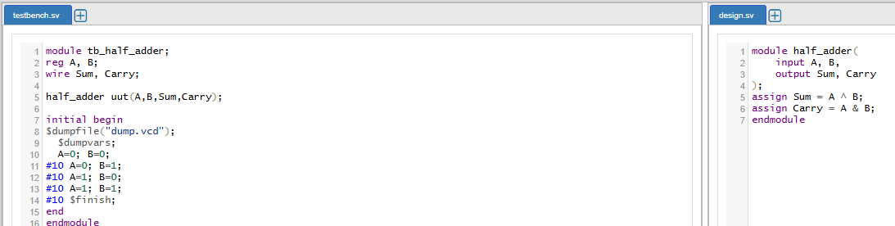
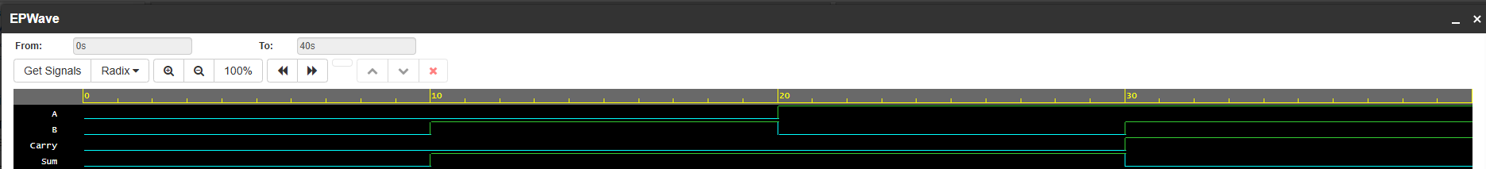

Task 3
Full Adder
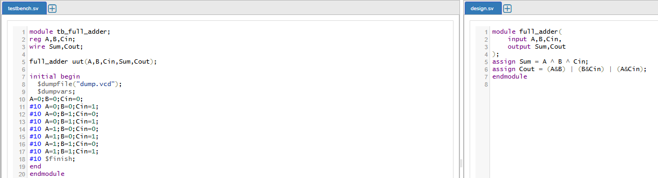
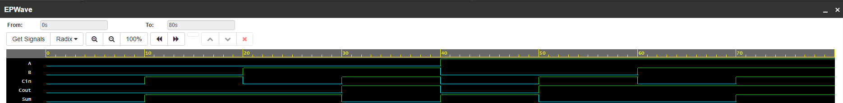
Task 4
Half Subtractor
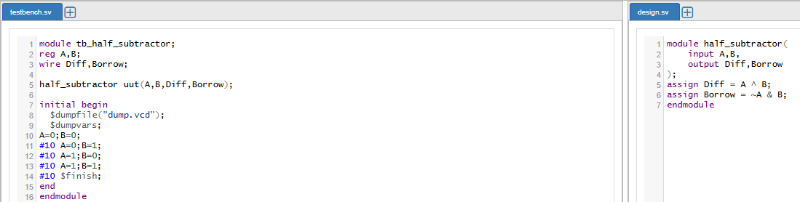
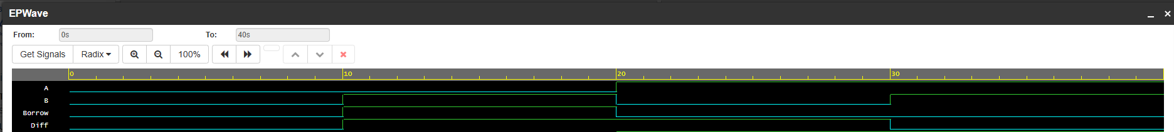

Task 5
Full Subtractor
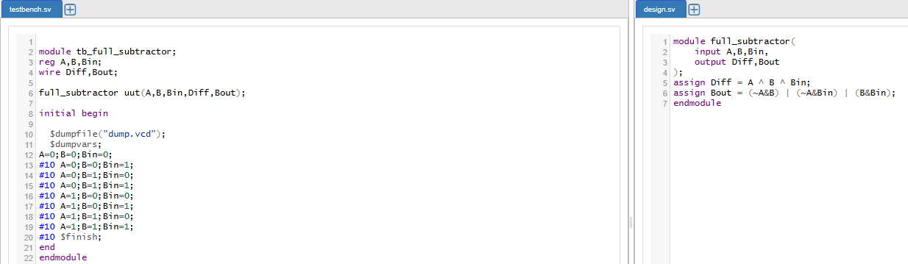
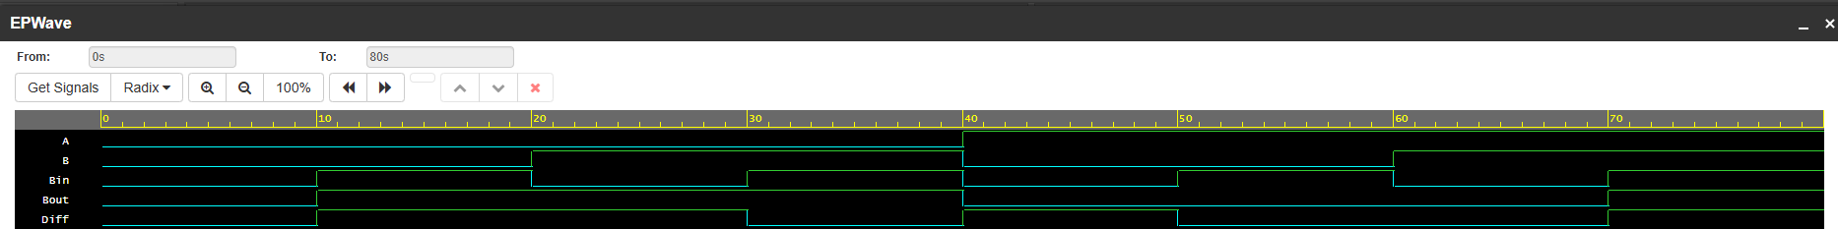
Task 6
Mux 2*1
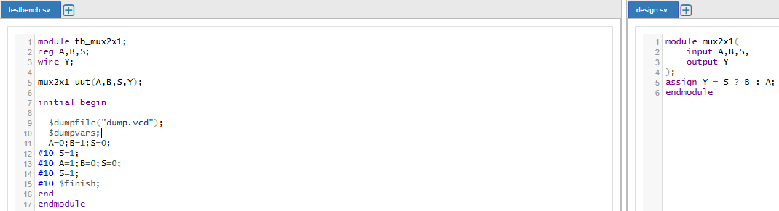
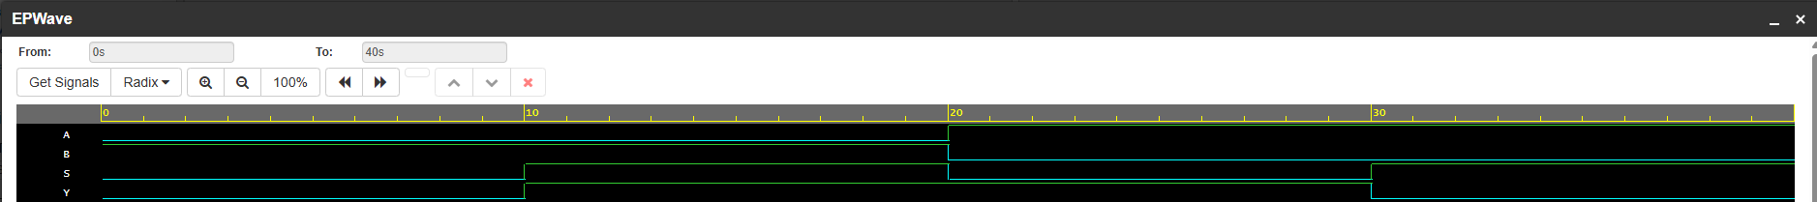

Task 7
Mux 4*1:
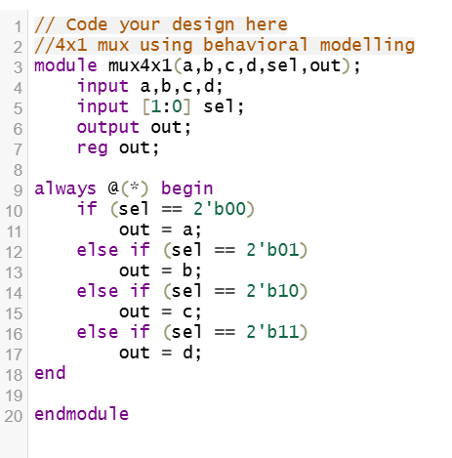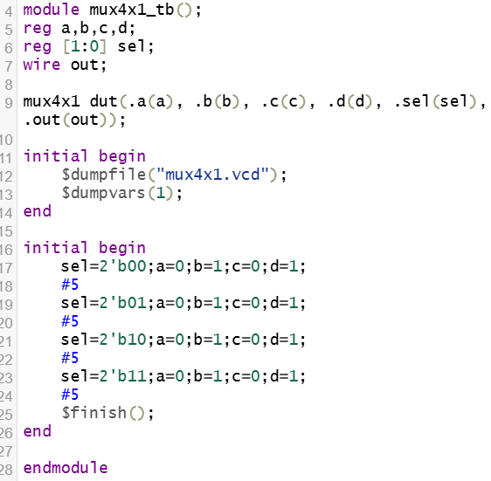
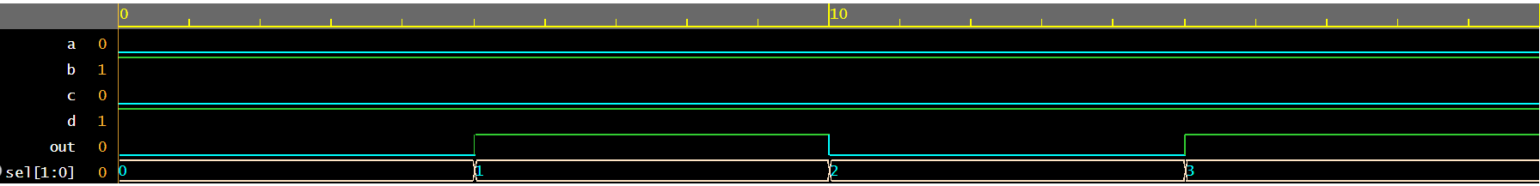

Task 8
4 to 2 Encoder
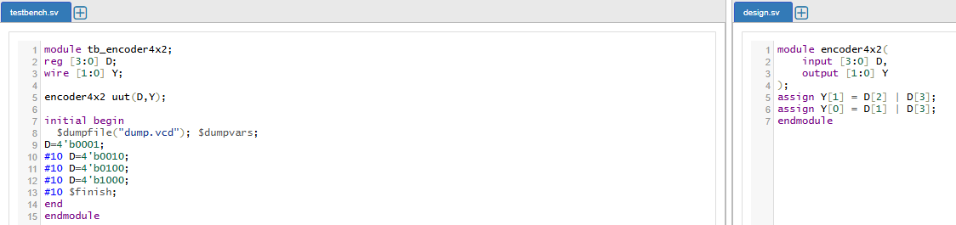
Task 9
2 to 4 Decoder
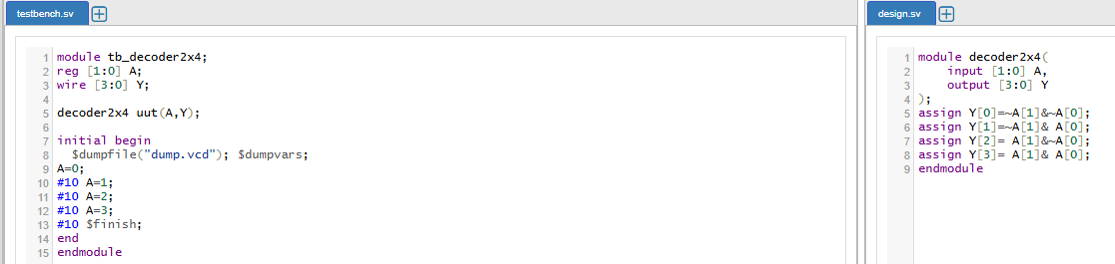

Task 10
BCD to 7 Segment
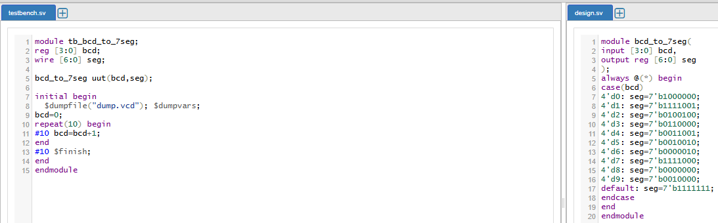
Task 11
Priority Encoder:
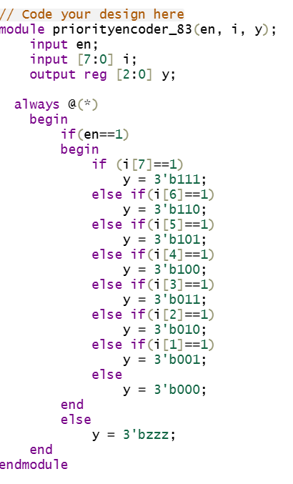
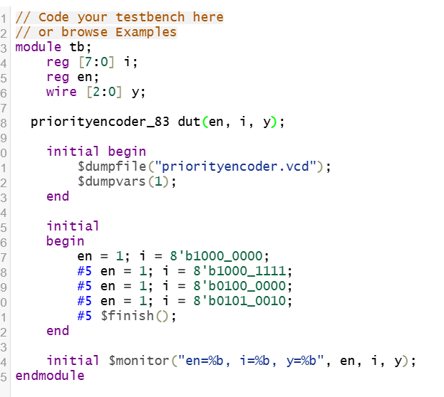
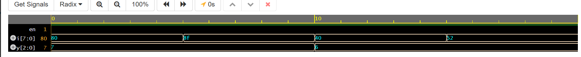
Task 12
Priority Decoder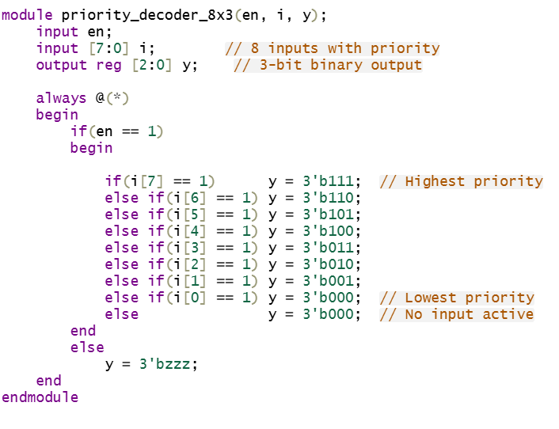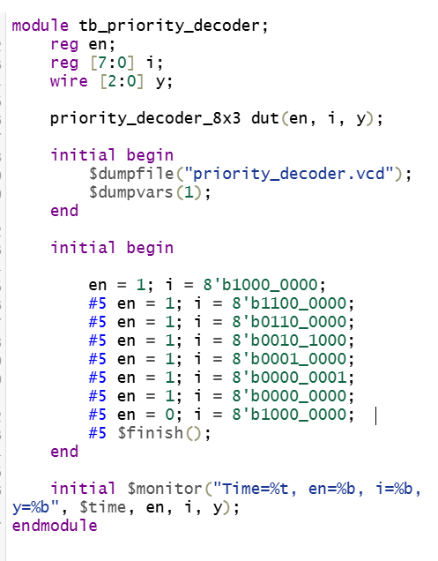

Task 13
2x2 Multiplier
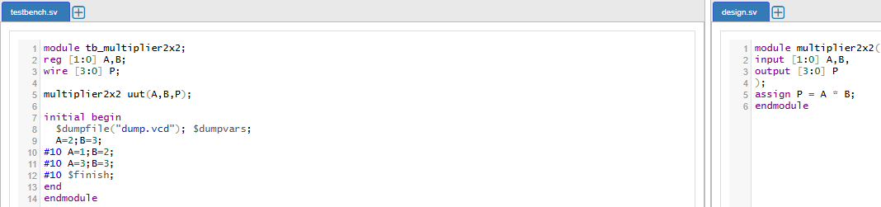
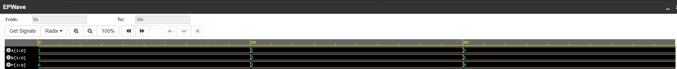
Task 14
4-bit Binary Adder
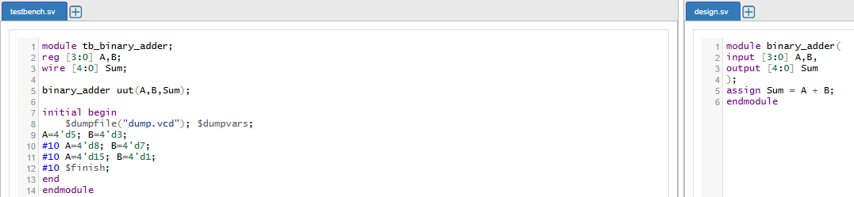
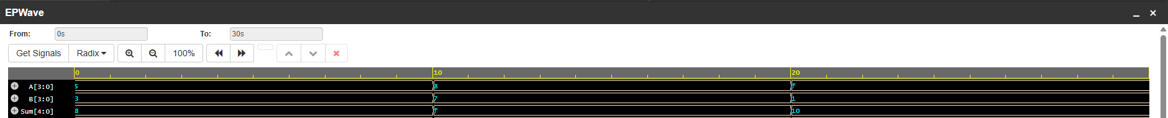
Task 15
4-bit Binary Subtractor
